Vehicle Network Sync v. 0.3

Overview
This document states what the driving foundation requires from the networking layer. It does not choose a networking model.
Every networking decision has been moved into the Matchmaking & Lobby System document, where the options and their consequences are laid out for the development team to rule on during implementation. That includes the authority model, the tick rate, interest management, hosting architecture, rollback depth and the correction thresholds. This document exists so that whichever way those rulings go, the team knows exactly what the driving simulation needs in order to work.
The core requirement is that two robots in contact at speed produce the same outcome on both screens. That is harder than it sounds, and harder than anything the lobby itself has to satisfy. A waiting-room roster that resolves half a second late is invisible. A bump that resolves differently on two screens is the single most noticeable failure this platform can produce, and it is the failure players describe as “the game is broken” rather than “the game is laggy”.
The whole document set was written against the constraints below. The Drive Model’s determinism contract, the Drift & Boost economy’s tick-based state, Handling Profiles’ pure per-tick composition, and Collision’s contact authority section are all downstream of this document. Where those documents say “this must be deterministic” or “this must be networked state”, this is the document explaining why.
Photon Fusion 2 provides prediction, rollback, tick alignment and interest management as first-class features. Nothing here proposes writing a netcode layer. The goal is to use what Fusion already does correctly, and to state precisely what the rest of the foundation must do so that it can.

Requirements
Numbered so they can be referenced from a decision discussion.

R1 — Local input responds without perceptible delay
The local player’s own chassis must respond to input on the tick the input was given. A driving game where the robot responds a round trip after the key is not shippable at any latency. In practice this means client-side prediction of the local chassis, whatever else is chosen.

R2 — A contested contact resolves identically on both screens
One authority per chassis-to-chassis contact, replicated to both participants, with any correction absorbed visually rather than snapped.

R3 — Corrections are never visible as a snap
Whatever the reconciliation approach, a corrected position blends over a short window. A teleporting robot is worse than the error it corrected.

R4 — Remote chassis move smoothly at all times
No stutter, no rubber-banding, no visible tick stepping, at any supported latency. In practice this means rendering remote chassis slightly behind the latest received state and interpolating between states rather than predicting them.

R5 — Every simulation-relevant value is networked state
Nothing feel-critical may be local. The complete list is below.

R6 — The simulation is a pure function of state and input
Given the same starting state and the same input, every peer produces the same result, every time, including on a re-simulation after a correction.

R7 — A player with a poor connection degrades gracefully and does not degrade anyone else
Their own experience gets worse; the other players’ does not.

R8 — Determinism is enforced, not merely stated
A violation produces intermittent desync that is misdiagnosed as a physics bug for weeks. The enforcement section below specifies how violations are caught.

The Input Struct
The input struct is the only thing a client sends. It must be small, complete, and contain intent rather than results.
NetworkInput {
SteerAxis // quantised to 8 bits
Buttons // bitfield: Throttle, Brake, Hop, Boost, Respawn
Tick // implicit in Fusion's input handling
}
Intent, not results. The client sends “boost pressed”, never “boost fired”. Whether a boost press falls inside the release window is a simulation question, and it must be answered identically by every peer from the same replicated drift state. A client that sends “I fired a stage 3 boost” is a client whose prediction and the authority’s result can disagree with no way to reconcile — and, secondarily, one that can trivially be modified to always send that.
Steering is quantised to 8 bits. The Drive Model treats the steer axis as a target approached over time, so 256 steps is well below the resolution any player could detect, and it costs a byte.

Networked Chassis State
Everything below must replicate and must survive a correction and re-simulation. This is the complete list; anything not here is local and may not affect simulation.
NetworkedChassisState {
// Drive Model
Position // compressed
Rotation // yaw-dominant, compressed
Velocity // compressed
AngularVelocity // yaw only
IsGrounded // 1 bit
SurfaceTag // 4 bits, small enum
SmoothedGrade // quantised. Accumulates across ticks, so it must replicate
// Drift and Boost
DriftPhase // 3 bits
DriftDirection // 1 bit
Reserve // quantised
ChargeStage // 2 bits
PhaseTicksRemaining // small int
ChainCount // small int
ActiveBoostMultiplier // quantised
// Collision and Recovery
IsSpinningOut // 1 bit
RecoveryTicksRemaining
ImmunityTicksRemaining
SettleHeading // quantised
// Profiles
RobotID // set at spawn, not per tick
ActiveModifiers[] // id plus ticks remaining, small
}
Suspension state is deliberately absent. Probe compression, chassis lean and ride height are cosmetic and are recomputed locally from position and geometry. They affect nothing in simulation.
Air ticks are derived, not replicated. IsGrounded is networked; the consecutive count is recomputed from it.
SmoothedGrade is easy to miss. It is the one value in the Drive Model that accumulates across ticks, and a smoothing buffer that is not restored on a rewind will produce a different slope reading on re-simulation. It is called out separately because it is the kind of thing that gets added later without anyone noticing it needs replicating.

What the Foundation Owes the Network Layer
These are obligations on the simulation modules, not on the networking implementation.
Requirement | Why
The simulation is a pure function of (state, input) | A re-simulation restores state and re-runs. Anything the re-run reads that is not in restored state produces a different answer the second time
No accumulated engine state | The Drive Model integrates its own velocity rather than relying on PhysX solver internals persisting, because those internals are not restored on a rewind. This is also why inertia stays out of the rigidbody’s inertia tensor
Profile composition is pure per tick | A composition that remembered anything about prior ticks would resolve differently on re-simulation
Every accumulating value is replicated | SmoothedGrade today; anything similar added later inherits this rule
Surfaces sampled by raycast, never by trigger callback | Trigger enter and exit fire on the engine’s schedule, not the tick’s, and do not replay on a rewind. This is the single most likely determinism violation in the set and it is designed out rather than warned about
No unseeded randomness anywhere | Where variation is wanted, it is a deterministic function of tick number and PlayerRef
Fixed step, always | Nothing in the simulation reads render-frame delta time. The camera is the sole exception, and it only reads simulation state, never writes it
Profile values authored in per-second terms | Converted at load against the chosen tick rate, so a tick rate change does not silently retune every chassis

Contact Authority Split
The requirement from Collision, Contact & Recovery, restated as a networking concern.
Contact type | Requirement | Reason
Chassis-to-chassis | One authority resolves; both participants reconcile | Two chassis, two owners, one truth
Chassis-to-world | May be resolved locally on every peer | Walls do not move and every peer has identical geometry, so wall contact is deterministic from the chassis’s own replicated state. Wall contact is far more frequent than chassis contact, so this is a meaningful saving under any model
Chassis-to-prop | Local, non-authoritative | Props are cosmetic. Divergence has no simulation consequence
Out of bounds and stuck | Authoritative | Triggers a respawn, which other players see
Prediction of chassis contact will be right most of the time, because both peers have the other chassis’s replicated state and classification is a pure function of it. It is wrong when two chassis are converging fast and the client’s view of the remote chassis is a few ticks old — precisely the contested-bump case. This is why R3 is a hard requirement rather than a polish item.

Illustrative Pipeline
The diagram below shows the shape of a client-predicted, authority-reconciled tick. It illustrates one approach rather than specifying it — the ruling on which model to use is in the Matchmaking & Lobby System document. It is included here because the requirements above are easier to read against a concrete example.
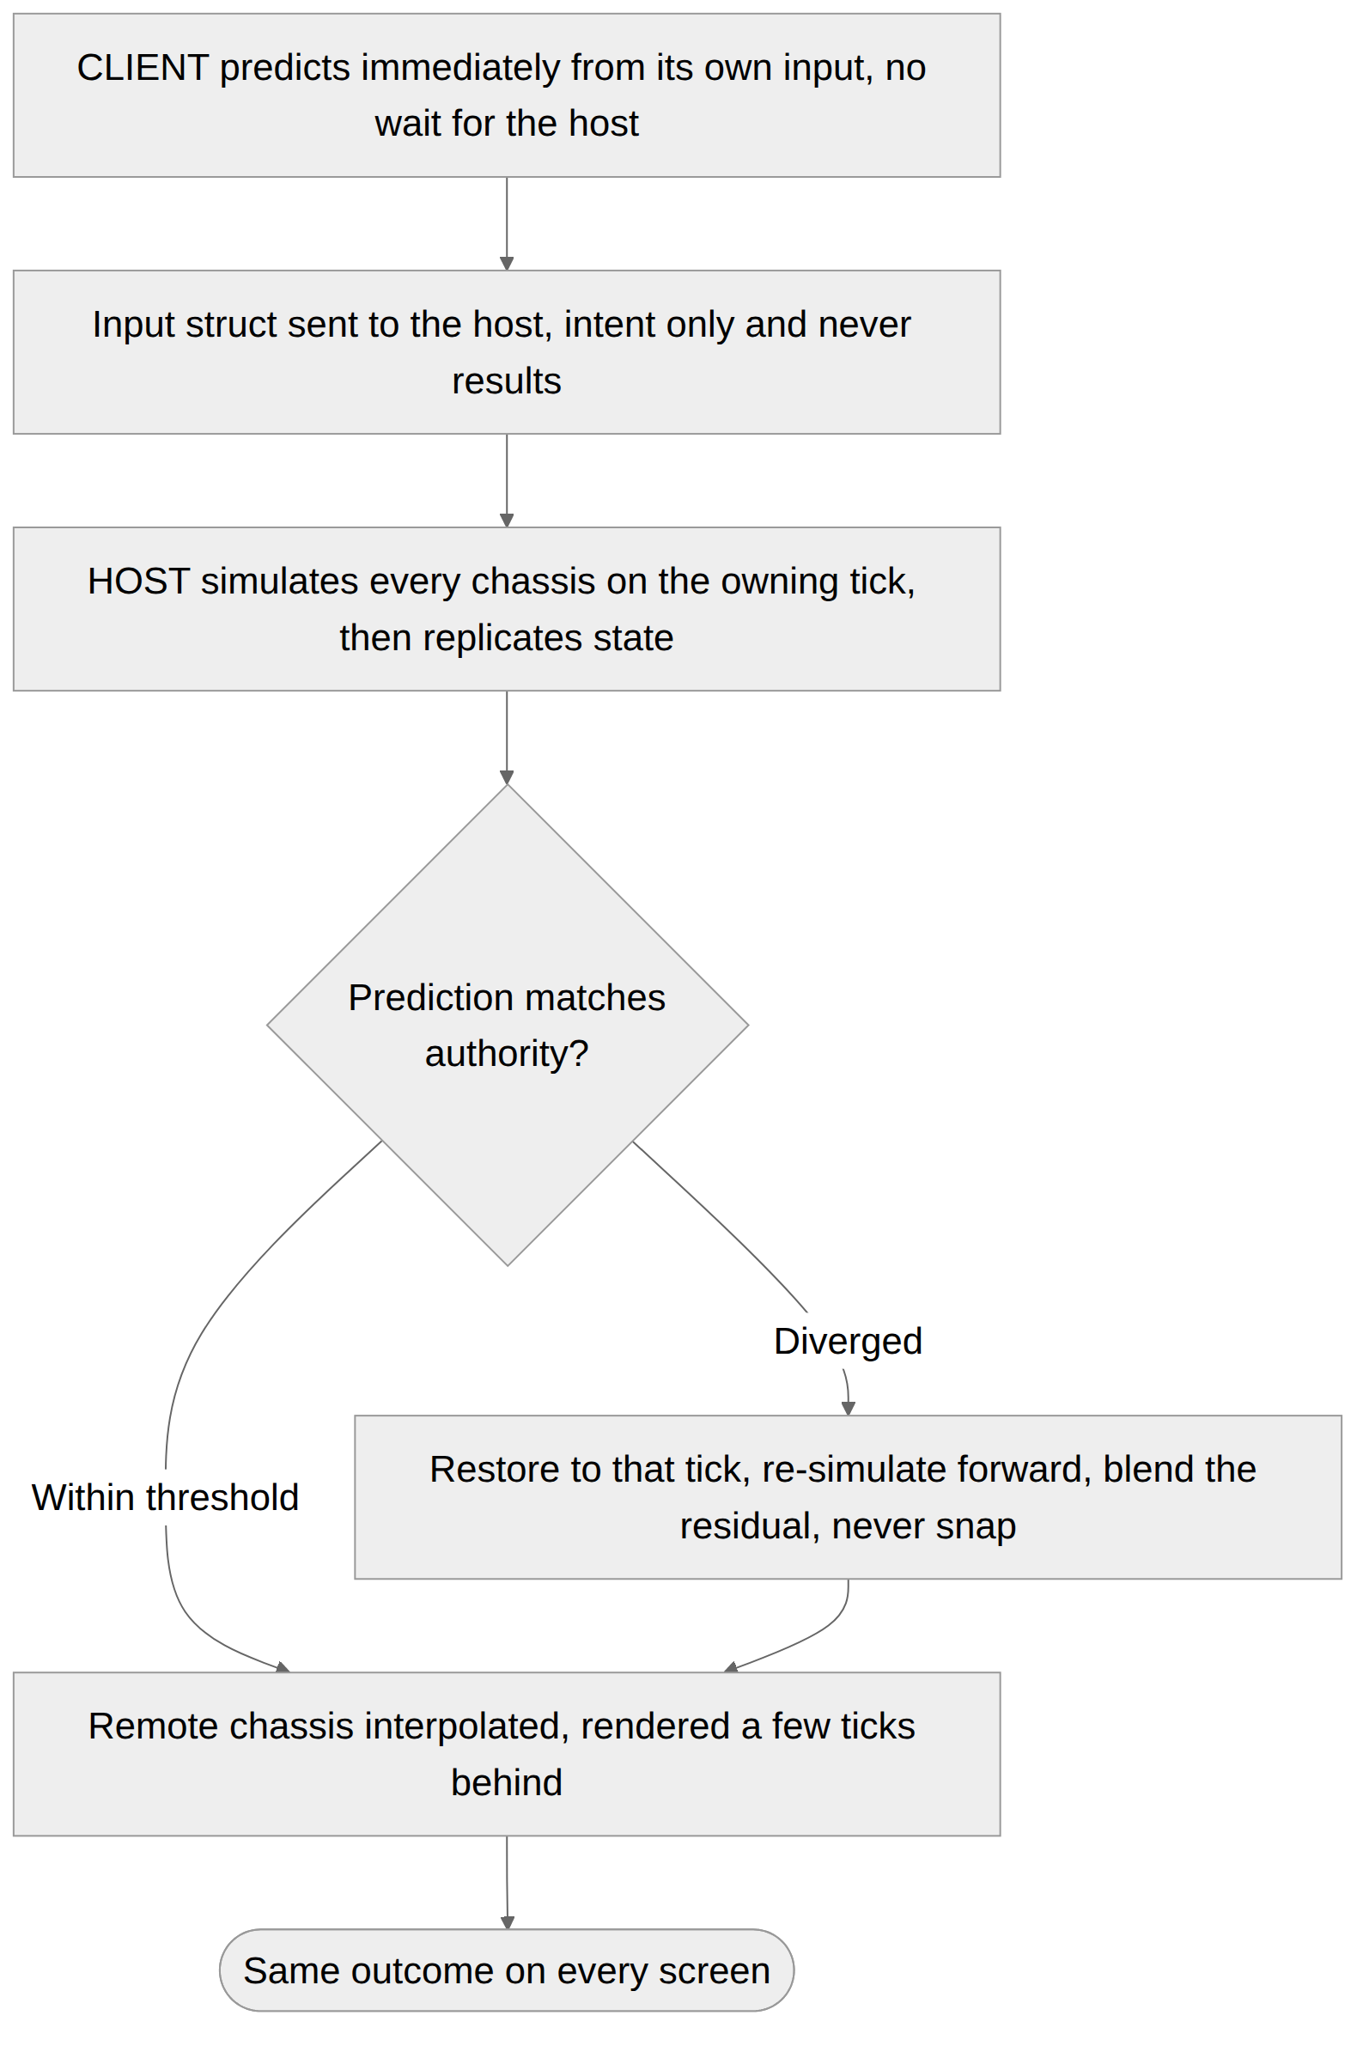
Stage | What happens
1. Input capture | Device input resolved into a NetworkInput struct for the current tick
2. Local prediction | The full drive, drift and contact pipeline runs immediately against local state
3. Input send | The input struct is sent. Fusion batches and redundantly sends recent inputs to survive loss
4. Authoritative simulation | The authority runs the same pipeline for every chassis, on the tick the input belongs to
5. State replication | Networked chassis state for the resolved tick is sent to all clients
6. Reconciliation | Client compares its predicted state against the authority’s. On a mismatch, it restores and re-simulates forward
7. Correction blend | Any remaining visual difference is absorbed over a short window rather than applied instantly
8. Remote interpolation | Other players’ chassis are rendered slightly behind and interpolated
The asymmetry is the point. The local chassis is predicted and reconciled, so it feels instant and is occasionally corrected. Remote chassis are interpolated and never predicted, so they are smooth and slightly behind. Predicting remote chassis to remove that delay produces jitter every time another player changes input, which is worse than the delay it removes.

Determinism Enforcement
Requirement R8. Stating the rules is not enough, because a violation is silent until it is expensive.
- State hashing in development builds. Every chassis’s networked state is hashed per tick on every peer. A mismatch is logged with the field, the tick and the magnitude, so a determinism violation surfaces as a named field on a named tick rather than as “the game desyncs sometimes”.
- A soak test in continuous integration. Two headless clients, a fixed input script, a fixed number of ticks, hashes compared at the end. Any divergence fails the build. This is the single highest-value engineering investment in the whole document set, because it converts the most expensive class of bug in the foundation into a build failure.
- A determinism review on any change to the simulation path. The Drive Model, Drift & Boost, Collision and profile composition are all inside the simulation path. Any change to them is reviewed against the rules above.
- Fusion API confirmation. The API surface referenced across this set reflects Fusion 2’s documented behaviour. Engineering should confirm exact signatures and semantics against the SDK version pinned in the project before implementation.

Bandwidth Requirements
Stated as a budget the networking decisions must fit, not as a decision itself.
Item | Target
Input, per client per tick | ~2 bytes plus Fusion overhead and redundancy
Networked chassis state, per chassis per tick | Under 40 bytes compressed
At 4 players, 60 Hz | Under 12 KB/s down per client before Fusion overhead
At 8 players, 60 Hz | Under 24 KB/s down per client
The eight-player case at 60 Hz is the one that should be measured on a prototype before the tick rate is committed. The levers available if it does not fit — tick rate, compression, interest management — are presented as options in the Matchmaking & Lobby System document.
On tick rate and the drift window. At 30 Hz, the default window_ticks of 24 becomes 0.8 seconds rather than 0.4, and every other tick-denominated value in the set doubles in wall-clock terms. Profile values are authored in per-second terms and converted at load precisely so a tick rate change does not silently retune every chassis — but the drift release window is an input-timing value, and its wall-clock duration genuinely changes how the game feels. The tick rate ruling should therefore be made before the Drift & Boost tuning pass, not after, or that pass will need repeating.

Edge Cases
Stated as behaviours the foundation expects, whatever model is chosen.
- A client’s input arrives after the authority has already simulated that tick. The last known input is substituted for the missing tick and the client reconciles when it receives the result. Repeated occurrence is a bad connection and degrades only that player, per R7.
- A client predicts a bump that the authority resolves as a miss. The client’s chassis is reconciled to the un-bumped state and the difference blends. The other player, who never predicted being hit, sees nothing. This is the common case and the reason R3 exists.
- A client predicts a miss that the authority resolves as a bump. The client is reconciled into a spin-out it did not predict. Recovery state is replicated rather than locally triggered, so the state itself is not the problem; the position difference is, and it blends.
- Two clients each predict winning the same head-on. Both are reconciled to the mutual-shove result. Neither sees a winner, which is the correct outcome.
- Latency exceeds the maximum rewind depth. Re-simulation is impossible, so the client hard-corrects with a blend. Visible, rare, and the graceful degradation path of R7.
- A transient modifier expires during a rewound span. Modifier expiry is by replicated tick count, so re-simulation applies and expires it identically. This is why Handling Profiles specifies expiry by tick rather than by timer.
- A player respawns on a tick that is later rewound. Respawn is authoritative and replicated, so the client’s re-simulation reproduces it from replicated state rather than re-deciding it.
- Packet loss during a boost chain. Chain count is replicated state, not derived locally, so a lost packet delays the visual rather than breaking the chain.
- A modified client sends impossible input — steer axis outside range, or all buttons every tick. Input is clamped on receipt and the authority simulates from clamped values. There is no anti-cheat in this foundation beyond input clamping and the intent-not-results rule, which is the appropriate level for the platform today.

Open Decisions
None in this document, by design. Every networking decision previously raised here — authority model, tick rate, interest management, hosting architecture, rollback depth, reconciliation thresholds, disconnect handling — has been moved into the Matchmaking & Lobby System document, where it is presented as an option set with its consequences for the development team to rule on.
This document should be read alongside that one. It defines the constraints those rulings have to satisfy.

Integration Notes
- Requires: Photon Fusion SDK integrated at project level. A resolved set of networking rulings from the Matchmaking & Lobby System document. The Vehicle Drive Model’s determinism contract, which this document enforces.
- Integrates with: Every simulation module in the set. Collision, Contact & Recovery most directly, since contact authority is the requirement this document exists to satisfy. Handling Profiles, through transient modifier replication.
- Affects: Every module in the set, through the determinism rules. The build pipeline, through the continuous integration soak test.
- Does not cover: Any networking decision. Matchmaking, session creation or the lobby. Anti-cheat beyond input clamping. Dedicated server infrastructure. In-match voice or text.
- Follow up: Confirm the Fusion 2 API surface against the pinned SDK version. Measure the eight-player bandwidth case before the tick rate is committed.

Success Metrics
- The local chassis responds to input on the tick the input was given, at any supported latency
- A contested bump produces the same outcome on both participants’ screens, every time
- No correction is visible as a snap or teleport at any supported latency
- Remote chassis never visibly stutter or rubber-band under normal packet loss
- A continuous integration soak test of two headless clients over a fixed input script produces identical state hashes
- Per-client bandwidth at the maximum party size fits the stated budget
- A player on a poor connection does not degrade any other player’s experience
- Every value listed in NetworkedChassisState survives a full-depth rewind and re-simulation unchanged

Implementation Checklist
A milestone breakdown of everything specified in this document, so that a developer can confirm nothing was missed. Milestones are ordered so that each one is testable before the next begins. An item marked [D] is a decision or confirmation rather than code.
This document states requirements rather than making decisions, so its checklist verifies that the chosen networking approach satisfies them. The rulings themselves are checked in the Matchmaking & Lobby System’s M0.

M1 — Before any simulation code
☐ Every developer touching simulation code has read the determinism section
☐ Tick rate fixed
☐ Fusion 2 API surface confirmed against the pinned SDK version
☐ The contact authority split is understood, including resolving wall contact locally

M2 — Input
☐ NetworkInput carries steer axis and a button bitfield only
☐ Intent, not results — the client sends “boost pressed”, never “boost fired”
☐ Steer quantised to 8 bits
☐ Input clamped on receipt

M3 — Replicated state
☐ Every field in NetworkedChassisState replicated
☐ SmoothedGrade included — it accumulates across ticks and is easy to miss
☐ Drift phase, reserve, charge stage and chain count all replicated
☐ Spin-out and immunity timers replicated
☐ Transient modifiers replicated with their remaining ticks
☐ Suspension state not replicated — recomputed locally
☐ Air ticks derived from IsGrounded rather than replicated

M4 — Prediction and reconciliation
☐ Local chassis responds on the tick the input was given
☐ Remote chassis interpolated, never predicted
☐ Corrections blend over a window — never zero, never a snap
☐ Position and rotation thresholds below which no correction is applied
☐ Beyond maximum rewind depth, hard-correct with a blend
☐ Extrapolation on packet loss bounded, then hold position

M5 — Authority
☐ Chassis-to-chassis contact resolves on one authority
☐ Wall contact resolved locally
☐ Props non-authoritative
☐ Respawn authoritative and replicated

M6 — Determinism enforcement
☐ Simulation is a pure function of state and input
☐ No reliance on PhysX solver state persisting across ticks
☐ No unseeded randomness
☐ Surfaces sampled by raycast, never by trigger callback
☐ Fixed step everywhere except the camera
☐ State hashing per tick in development builds, logging field, tick and magnitude
☐ Soak test in continuous integration — two headless clients, fixed input script, hashes compared, divergence fails the build
☐ Determinism review required on any change to the simulation path

M7 — Verification
☐ Eight-player bandwidth case measured against the budget
☐ Contested bumps produce the same outcome on both screens, every time
☐ No correction visible as a snap at any supported latency
☐ Remote chassis never stutter or rubber-band under normal packet loss
☐ Soak test passing in continuous integration
☐ Every field in NetworkedChassisState survives a full-depth rewind unchanged
☐ A poor connection degrades only its own player

This document states requirements only. All networking decisions live in the Matchmaking & Lobby System document.

